# Running HEVSoLens Demo in the Immersive Analytics Room

## Turning on Nvidia Surround

1. Open Nvidia Control Panel (Right click on the desktop).

1. Select “Span displays with Surround” and click “Configure”. You may be asked to close some applications after clicking “Configure”.

1. Turn on Surround by clicking “Enable Surround”. You may need to wait a moment, do not click anything until the page starts responding again.

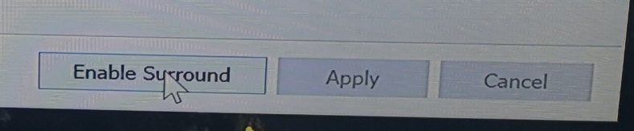

Match to these settings and press “Apply” (Note that you may need to change each setting one by one and press apply after each). Also set the order of the screens at the top. If the resolution 15360x2160 is not available, press the button next to it and add it.

1. You can now close Nvidia Control Panel.

## Updating IP address

1. This is only needed if your IP has changed from the PC’s initial “10.160.98.155” and the HoloLens’ initial “10.160.39.59”, or if using a HoloLens that is not “k46rs”.
2. The PC’s IP can be checked by opening command prompt and typing “ipconfig”. The HoloLens’ IP can be found on the HoloLens by going to Settings/Network, then clicking “Hardware properties”.
3. The files for the demo can be found on the desktop under “HEVSoLens Demo”.

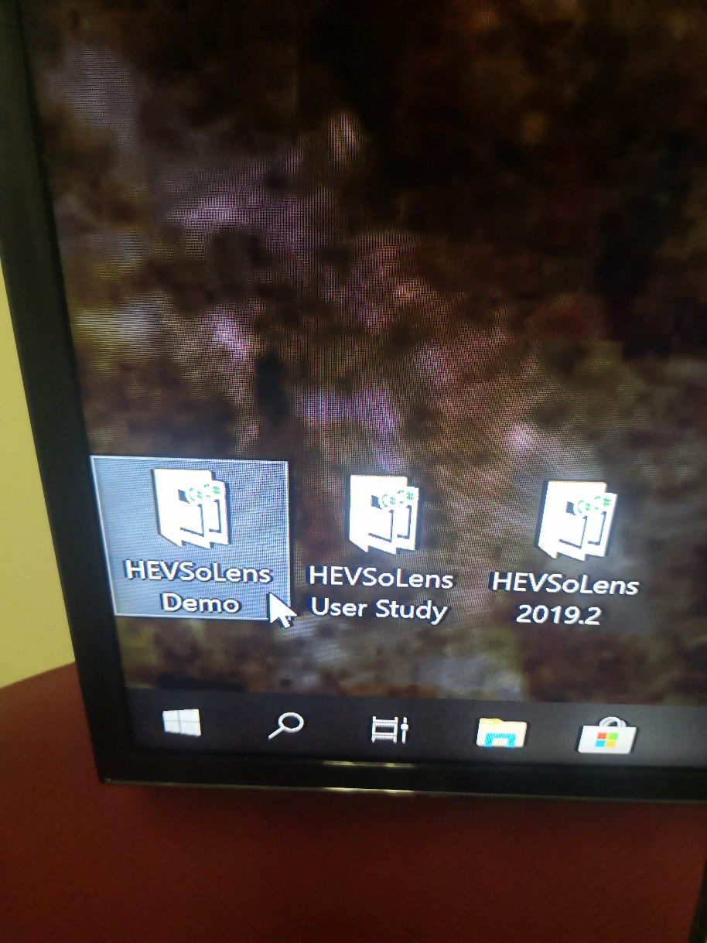

1. Open graph_config in both (or just open one and replace the other with a copy after)

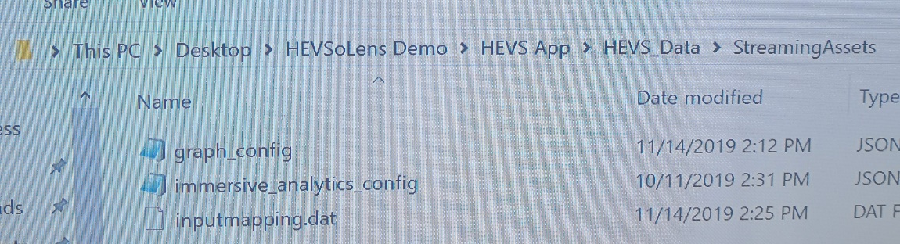

and

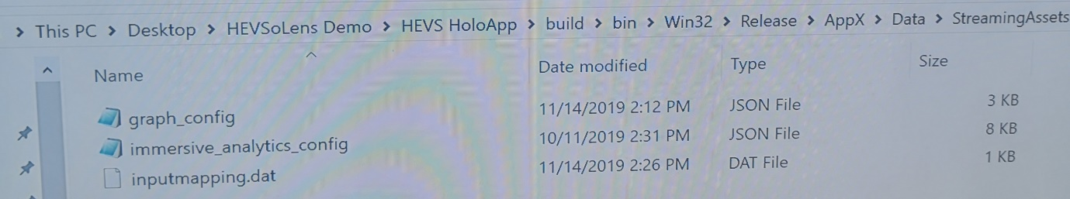

1. Replace “10.160.39.59” with the PC’s new IP.

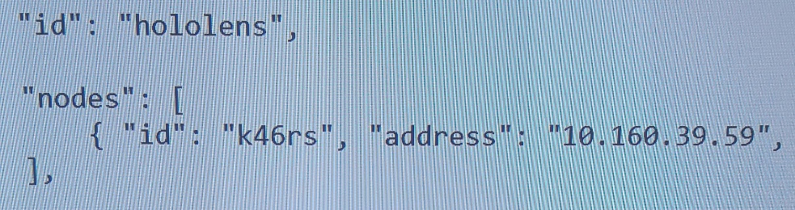

1. Replace “k46rs” with the HoloLens’ name and “10.160.39.59” with the HoloLens’ new IP.

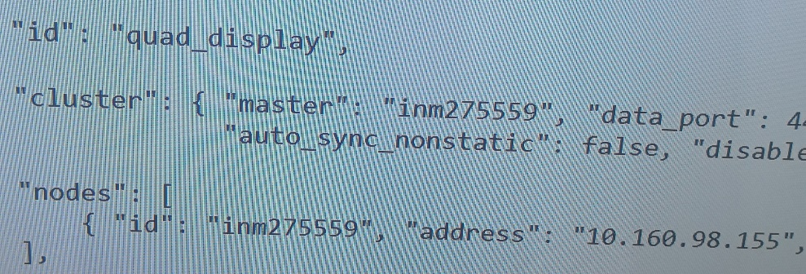

1. Open HEVSoLens HoloApp below.

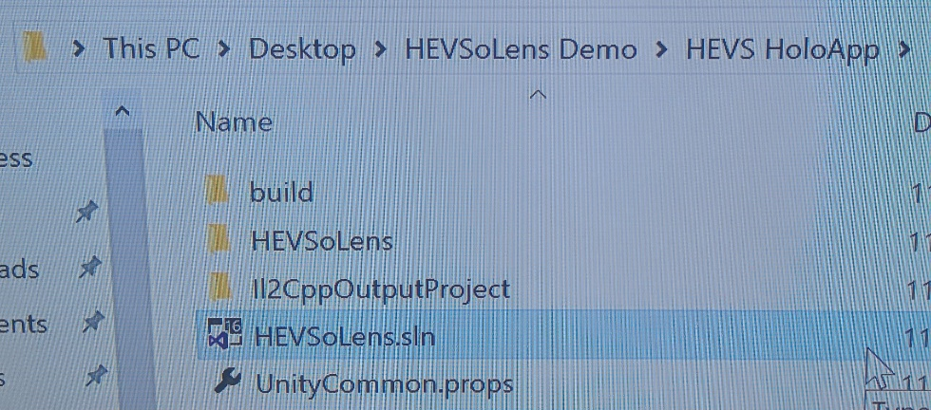

1. Make sure these that these settings are selected.

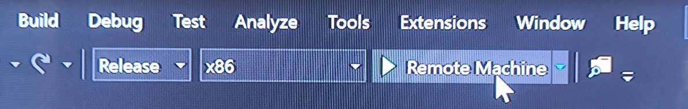

1. Then under Properties, Debugging, set the “Machine Name” to match the HoloLens’ new IP address.

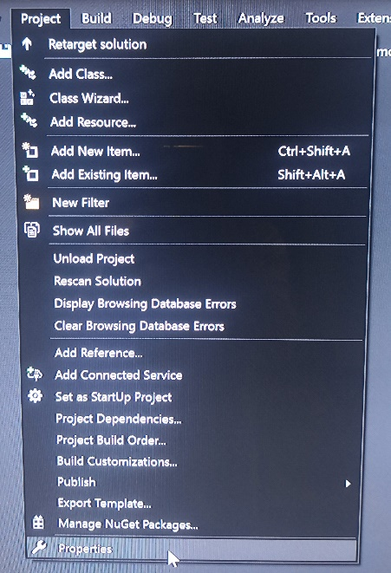 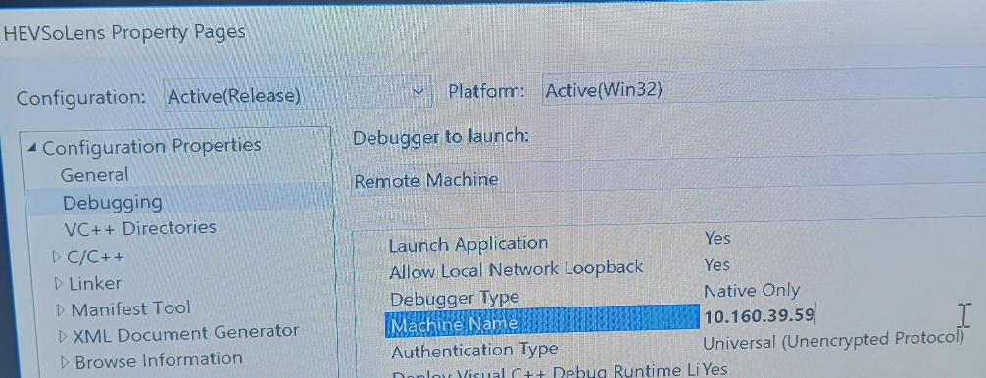

1. Then press “Remote Machine” to launch on the HoloLens (after launching once from the PC, you should be able to directly launch HEVSoLens from the HoloLens next time).

## Starting HEVSoLens Demo

1. Run “HEVS” in the “HEVS App” folder.

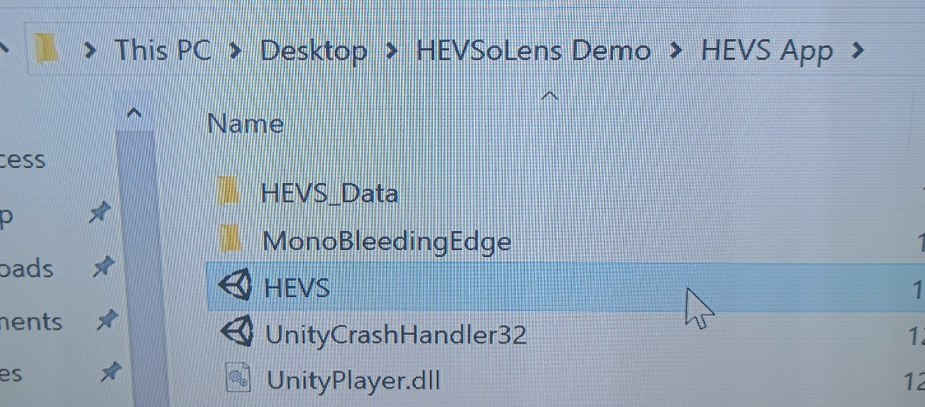

1. Run “HEVSoLens” on the HoloLens.
2. On the HoloLens, tap when the triangle is pointed at the middle of room to set the origin.